**BACKTESTING DETAILS**

**ENTRY :**

> Time frame: 1 min

>Consider Close price of Index (**banknifty**) at every 1 min Close and choose strike price

For ex: if Index Close is 39443--🡪Roundup to nearest number

So 39400

X=39400

Put option :X+300

Call option: X-300

>Check following criteria on these call and put options at every 1min

**Criteria: :**

**EXISTING CRITERIAS**

1. Close Price > Time series Forecast indicator (period : 3,Field : Close )

2.Stochastic RSI > 60

Stochastic RSI settings : period- 3

Overbought - 60

Oversold – 40

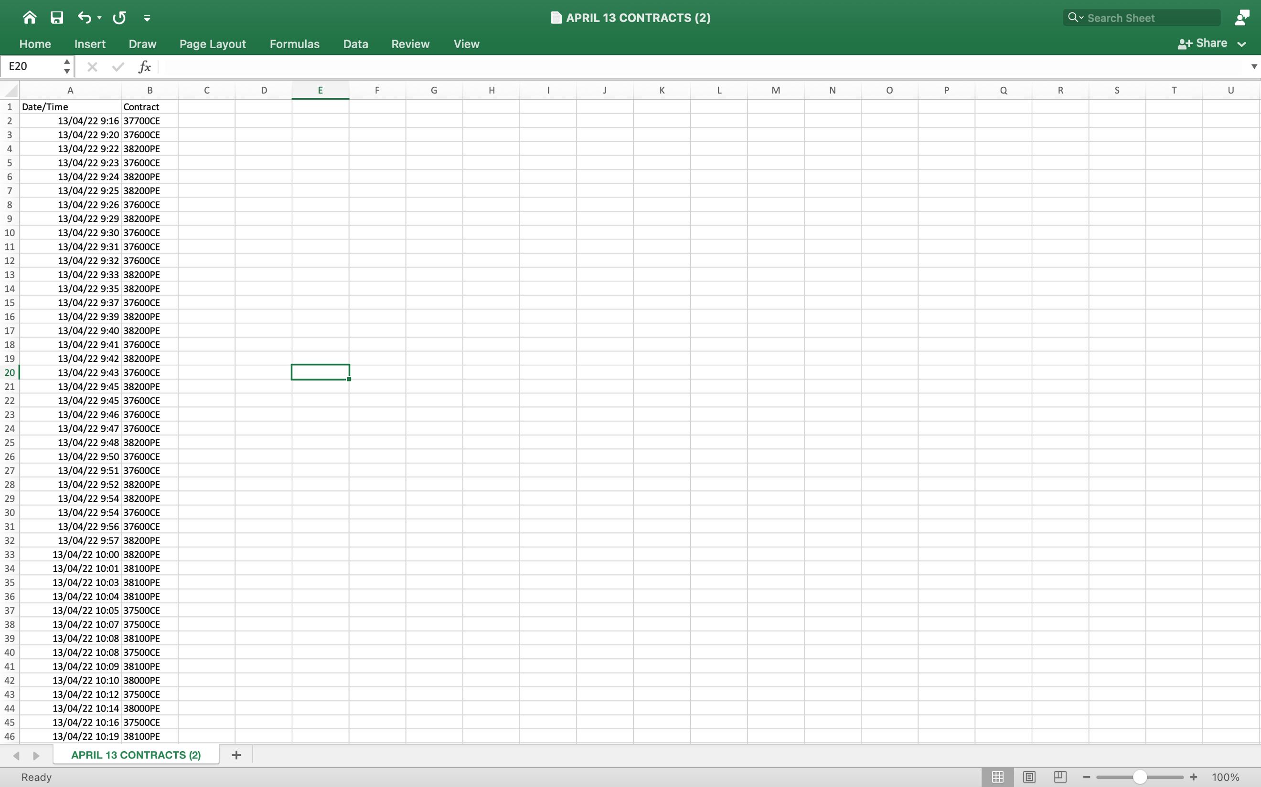

**SAMPLE CONTRACTS SATISFYING CRITERIA 1 & 2**

**NEW ADDITION**

**3.Remove Volume > Time series Forecast indicator (period : 3,Field : Volume )**

**A)**

**Volume > Simple moving average(Period:2/3/4/5)**

**B)**

**Volume of criteria minute > Volume of previous minute**

